**Research Question**

*A.  Summarize the original real-data research question you identified in task 1. Your summary should include justification for the research question you identified in task 1, a description of the context in which the research question exists, and a discussion of your hypothesis.*

The process of selling a home can be a difficult journey. This is especially true when it comes to the valuation process. Often, the real estate agent comes to the house and after much head scratching, makes an evaluation on the home without much quantitative insight. This can be frustrating to the owners of the homes, the brokerage, and the real estate agent when either the house won’t sell, or the house down the street with the same specs sells for a much larger sum. The question this research paper will answer is, can a multiple linear regression model be constructed that predicts the best. Sales price for a home?

The contribution of this study to the field of Data Analytics and the MSDA program is to create a predictive model which can estimate the valuation of a home in California. This will ensure that the company does not need to gather all data regarding home prices in the area to make a valuation on a home. With all of the houses for sale out there across the county, it would be impossible to have a sure knowledge of the real estate market, but regression analysis allows for an on-market valuation (Barr, 2018). Valkov (2021) shows that a model can be created to predict home prices using multiple linear regression and that is the hypothesis of this study.

**Data Collection**

B*.  Report on your data-collection process by describing the relevant data you collected, discussing one advantage and one disadvantage of the data-gathering methodology you used, and discussing how you overcame any challenges you encountered during the process of collecting your data.*

The data needed to answer this question is a publicly available dataset from Kaggle. According to Uslu (2022), “the vast majority of Kaggle datasets are reliable.”

<https://www.kaggle.com/datasets/yellowj4acket/real-estate-california>

The dataset contains the real estate listings for the state of California for the first 6 months of 2021. The data contains 35,390 rows of data and 39 columns. The independent variable from the data is the price of the house and the dependent variables include the rest. All are broken down as follows:

|  |  |
| --- | --- |
| Field | Type |
| ID | Categorical |
| stateId | Categorical |
| countyId | Categorical |
| Country | Categorical |
| DatePostedString | Categorical |
| Is_bankOwned | Categorical |
| Is_forAuction | Categorical |
| Event | Categorical |
| Time | Continuous |
| Price | Continuous |
| PricePerSquareFoot | Continuous |
| City | Categorical |
| State | Categorical |
| yearBuilt | Categorical |
| streetAdress | Categorical |
| Zipcode | Categorical |
| longitude | Continuous |
| Latitude | Continuous |
| hasBadGeocode | Categorical |
| Description | Categorical |
| Currency | Categorical |
| livingArea | Continuous |
| LivingAreaValue | Continuous |
| lotAreaUnits | Categorical |
| Bathrooms | Continuous |
| Bedroom | Continuous |
| buildingArea | Continuous |
| Parking | Continuous |
| garageSpaces | Continuous |
| hasGarage | Categorical |
| Levels | Categorical |
| Pool | Categorical |
| Spa | Categorical |
| isNewConstruction | Categorical |
| hasPetsAllowed | Categorical |
| homeType | Categorical |
| County | Categorical |

The advantages of this dataset is that it is very easily accessible to anyone as it is a public dataset. As stated before in this section, Kaggle datasets are pretty reliable. The data is already gathered and aggregated in such a way that it will make analysis of the dataset almost immediate. There are also some disadvantages to this dataset. As the data is already gathered, it impedes the ability for the researcher to choose which observations are most relevant to answering the research question. With the dataset being public, there is also the potential that the data may not be accurate or complete.

Usually, a researcher will decide on a research question and then gather the relevant data to answer this research question. In this study, the data is already gathered and then a research question was created based on the data. To overcome this challenge, the data will be thoroughly reviewed to come to a complete understanding of the observations therein. The data will also be cleaned and prepared before the analysis takes place.

**Data Extraction and Preparation**

C.  *Describe your data-extraction and -preparation process and provide screenshots to illustrate each step. Explain the tools and techniques you used for data extraction and data preparation, including how these tools and techniques were used on the data. Justify why you used these particular tools and techniques, including one advantage and one disadvantage when they are used with your data-extraction and -preparation methods.*

To extract and prepare the data, Python will be used in Jupyter Notebook. Python has modules that will do much of the heavy lifting work with the right code. The Pandas module allows for the use of data frames and read in the file. The Numpy module gives the analysis the use of arrays and operations. Both Pandas and Numpy make data handling very easy as opposed to R and SAS (*SAS vs R vs Python – The Battle for Data Science!,* n.d.).

The first step is to read in the dataset using Pandas

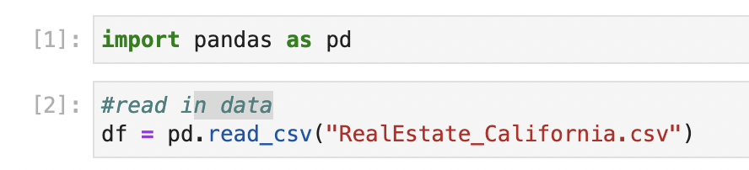

Pandas makes it easy to convert a CSV file to a data frame object. This makes it easy for future cleaning of the data and the actual analysis. The only disadvantage of this step is that it could be difficult to see the data as the file is simply a data frame object.

Next step is to check for null values

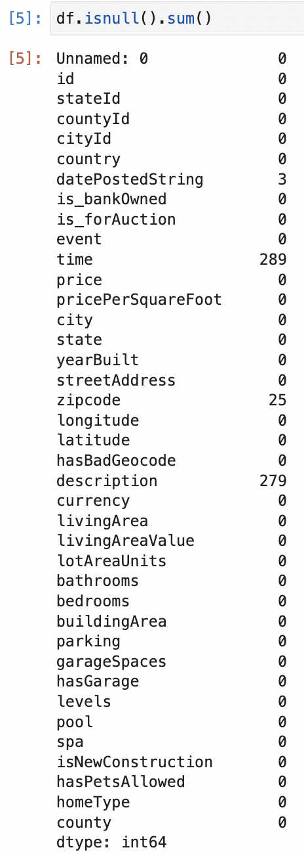

This code gives us a simple look into which features have null values as it sums up all of the null values and lines it up next to the name of the feature. This makes it easy to see where the null values need to be removed, however it doesn’t give much more information except the number of null values. It doesn’t note where the null values are.

Next, any duplicates are dropped from the data frame

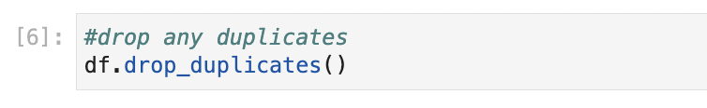

This is a simple way to drop any duplicates from the entire data frame in one simple line of code. It doesn’t require any more exploratory analysis more than this. Due to the simplicity of this technique, it doesn’t give much information regarding where the duplicate values were, or where they were removed.

The next step was to drop the variables that were not useful in the analysis



These variables were dropped for various reasons. DatePostedString, time, zipcode, and description were all dropped as they had null values and were deemed unnecessary for the analysis. Unnamed and Id were dropped as there were simply identifiers but not helpful in the analysis. StateId, country, state, county, currency, and city were dropped as these were either already in the data frame in another variable (cityId, countyId) or were unnecessary as all of the data was in the state of California and the US. Failure to remove the missing data will create bias in the model (Swalin, 2019). Dropping these variables gives us a more succinct set of data to work with. However, the removal of this data is not scientifically based but more based on intuition from what is known about the dataset.

Next, outliers were detected in the data.

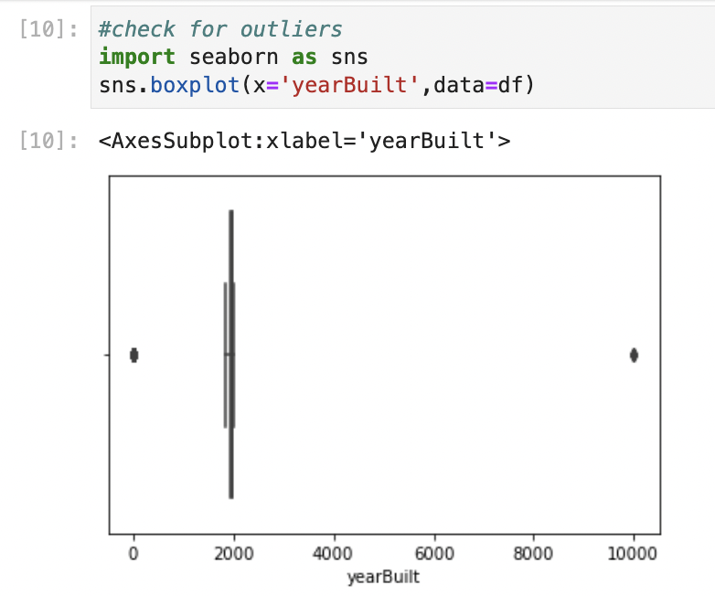

Not every graph will be shown in this research paper as there were many variables checked to identify outliers, but only one required cleaning and the rest were reasonable in their outliers. YearBuilt on the other hand, required some cleaning as it doesn’t make sense to be built in the year 9999 as seen above. Seaborn was used to visualize the outliers. This makes the outliers easily visible as the box plot shows where the interquartile range is. This does not, however, show us how many variables are outliers nor their actual values.

The next step will be to remove the outliers for the variable yearBuilt

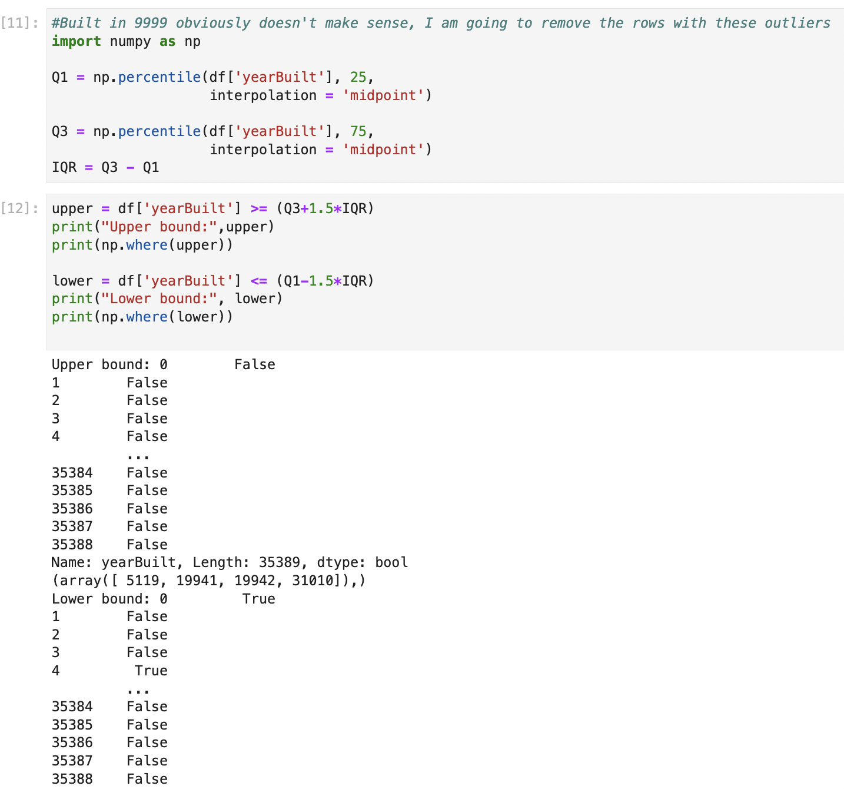

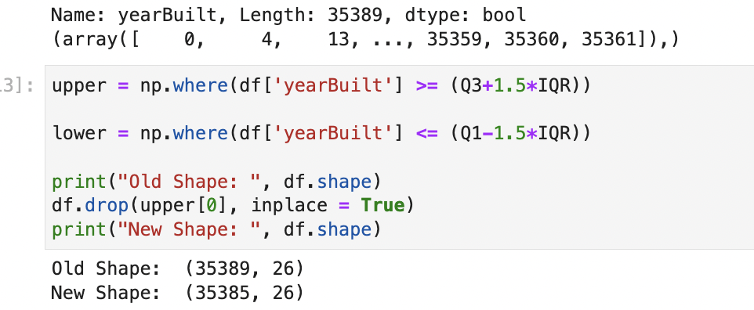

Numpy is imported to assist with the removal of these outliers. The observations in this variable will be saved in new data frame objects as the different quartiles: Q1, Q3, and IQR. These are then split into upper and lower and printed out to see the exact values of the outliers. It is noted that the outliers in the upper region only includes 4 observations. These are then dropped from the data frame. Dropping the outliers from the data frame ensures that the outliers do not cause bias in the analysis. This does, however, make the data frame smaller giving the analysis less data to work with.

The next step will require cleaning up the variable *levels* as it has high cardinality in its unique variables and many duplicates, just under different names

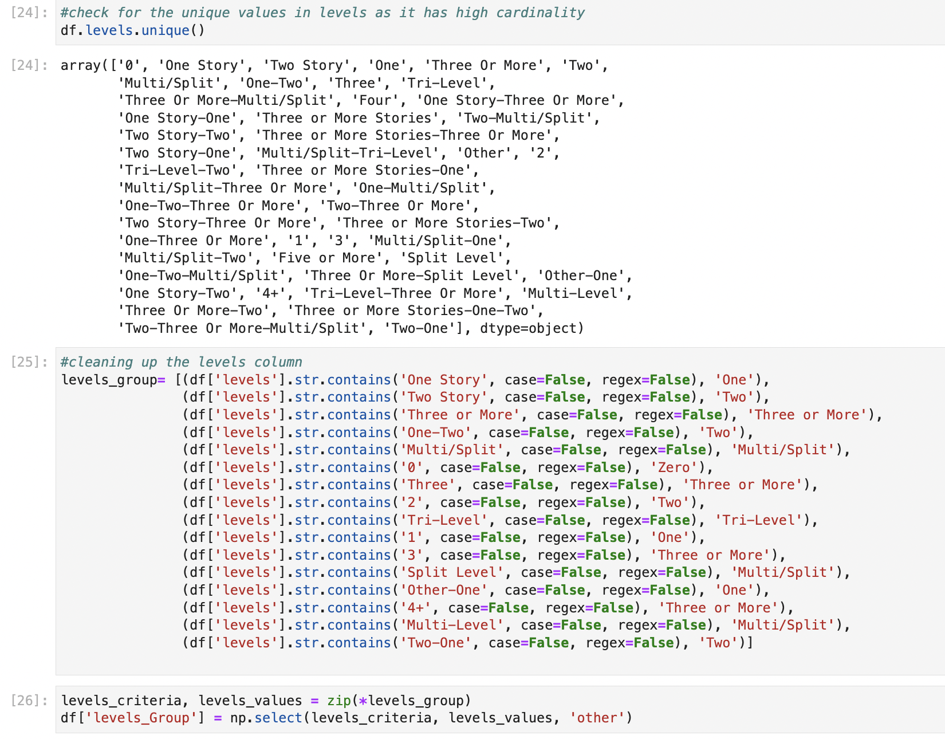

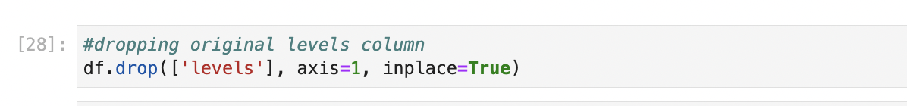

The first step required checking the unique values in the variable. There are many values that are the same, they just have different wording. For example, *One Story* is the same as 1 and *One.* To clean up this variable, a new data object was created under *levels_group*. Using np.select, conditions were created for the values and when the conditions are matched as true, the corresponding list of values are applied. In other words, np.select will look at the string values and apply a normalized string in its place. The list is then broken into two different lists using zip. The lists are then saved under the original data frame where each match is filled in with the new text value. If there is no match, it is assigned as *other.* The original variable *levels* is then dropped from the data frame. The use of np.select is very flexible as it can be used for numbers as well as strings, as was used in this case. The challenge of using this method is that it requires a lot of code.

The next step will be converting the categorical variables. The first step to do this will be creating a binary map for the variable *lotAreaUnits.*

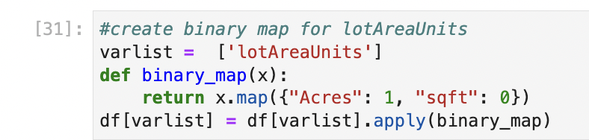

The purpose of creating a binary map is to map the variable features *Acres* and *sqft* to a numerical value of 1 and 0. This will ensure that the variable can be included in the analysis. As this variable only has two features, this is a simple way of ensuring the categorical variable is converted.

The next step in converting the categorical variables is to create dummy variables.

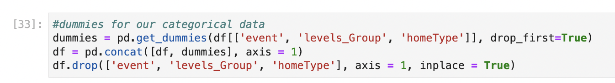

These dummy variables are created and the first is dropped as to avoid multicollinearity. These dummies are added to the original data frame and the original variables are dropped as they are not needed any longer. Dummy variables are helpful as they ensure all of the categorical variables are represented in a numerical value. The challenge could be that it can be hard to decipher what the dummy variables represent without much knowledge of the dataset.

Multiple regression makes the assumption that there is no multicollinearity in the variables. To ensure that there is not, a heatmap will be created to check for multicollinearity.

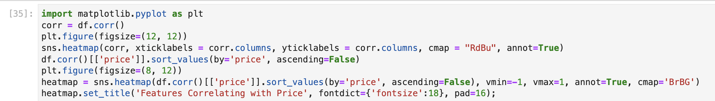

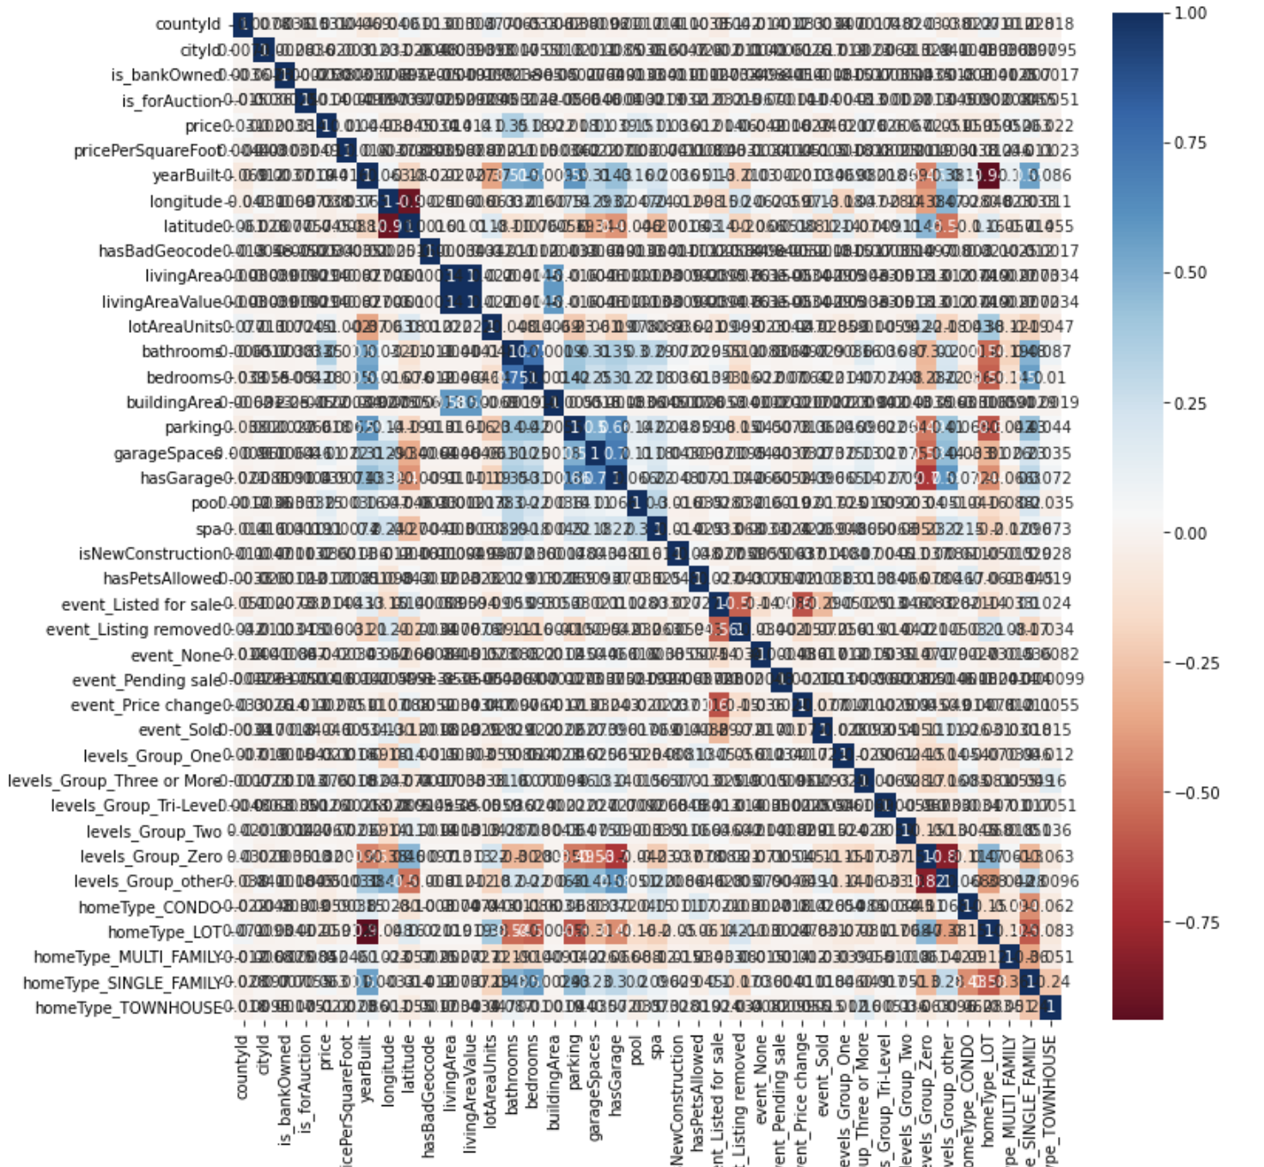

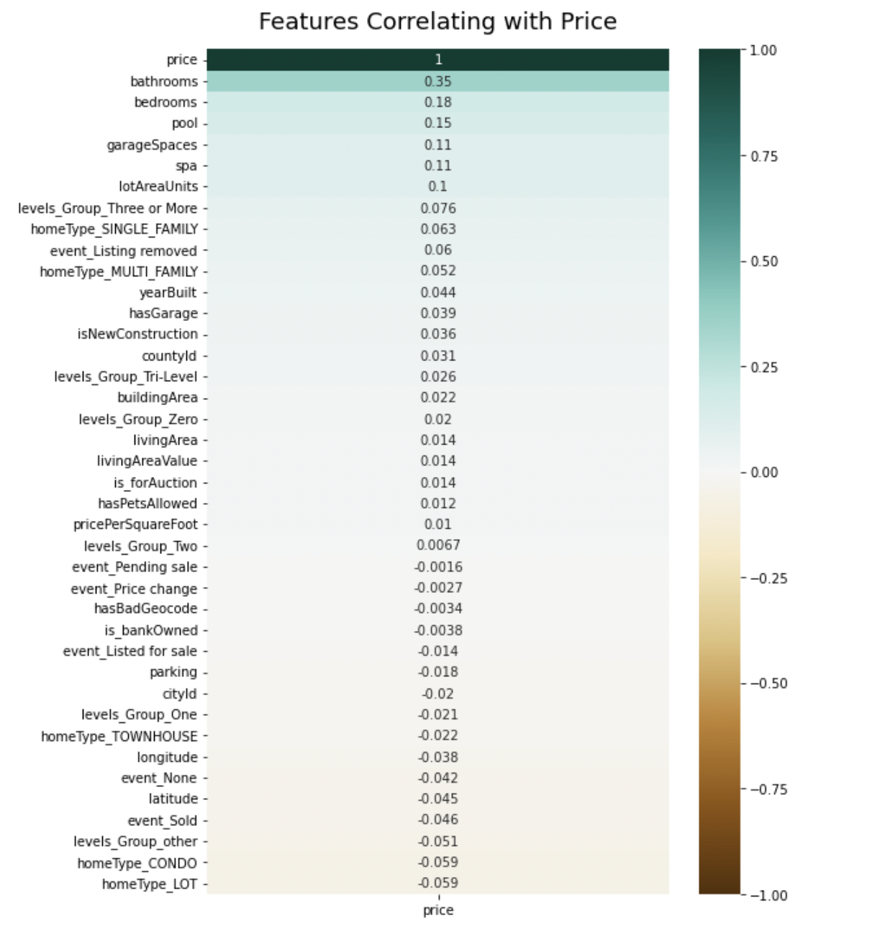



Matplotlib is imported to assist in the creation of the heatmaps. Seaborns is also used in the creation. The first heatmap incorporates the correlation between the variables. The darker the blue or red, the more correlated to the variables are and thus, should be removed. This method is an easy way to see which variables have multicollinearity and can then be easily dropped from the data frame. The second heatmap shows the correlation between the dependent variable against the independent variable. This heatmap is to ensure that no variables are dropped which may be highly correlated with the dependent variable. The disadvantage of this method is that it can become overwhelming with the number of variables in the data frame. It becomes difficult to decipher the correlation the more variables there are.

The final step in the data preparation is to remove variables with a high variance inflation factor. “Variance inflation factor (VIF) is a measure of the amount of multicollinearity in a set of multiple regression variables. Mathematically, the VIF for a regression model variable is equal to the ratio of the overall model variance to the variance of a model that includes only that single independent variable” (Potters, 2022).

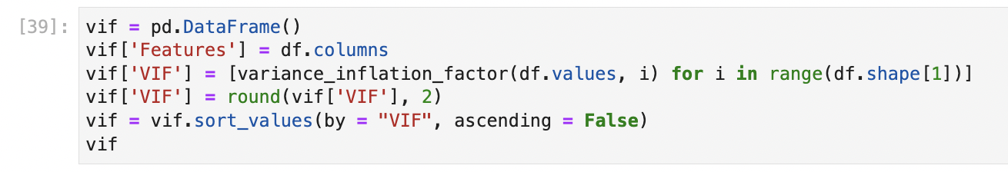

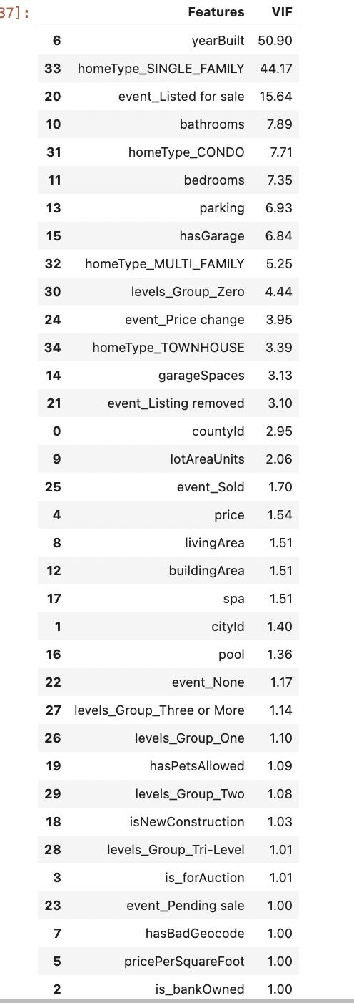

For this analysis, variables will be removed with a VIF over 10. This will ensure that there is no multicollinearity in the model. Multicollinearity in the model will make it so the independent variable is not statistically significant, so these variables need to be removed. This method ensures the VIF is easily visible and ordered in descending order. This challenge of removing variables with high VIF this way is it can require multiple steps as only a couple variables will be removed at a time.

In this case, three variables are removed from the data frame and the VIFs are calculated again.

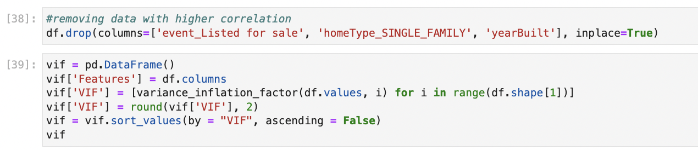

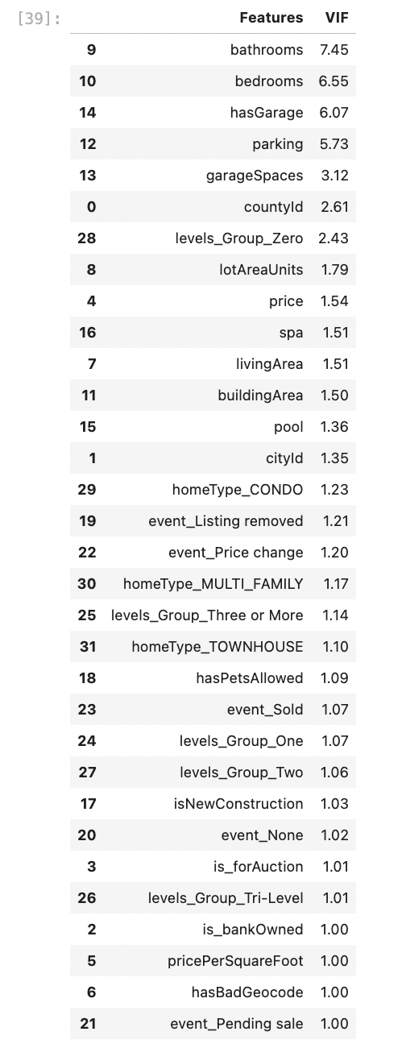

As the VIFs are now under 10, the data preparation stage is done.

**Analysis**

*D.  Report on your data-analysis process by describing the analysis technique(s) you used to appropriately analyze the data. Include the calculations you performed and their outputs. Justify how you selected the analysis technique(s) you used, including one advantage and one disadvantage of these technique(s).*

Now that the data is prepared for analysis, the model for multiple linear regression can be built. The first step is to split the data into train and test data.

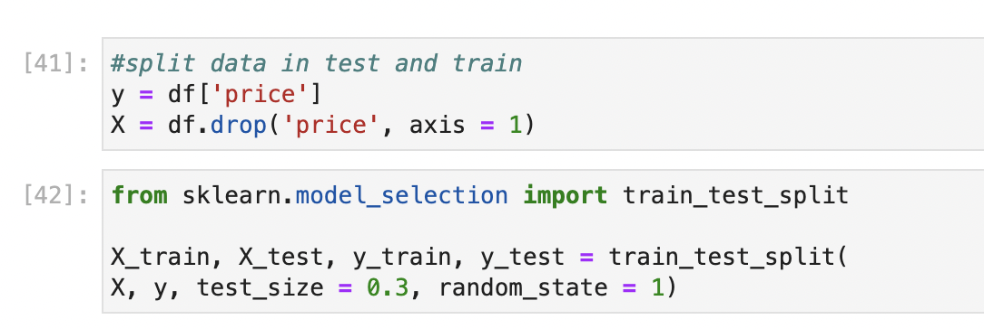

The data is split using sklearn at a 7:3 ratio. This prevents the model from overfitting. If the dataset for this analysis was not as large as it is, there would be no need for splitting the data. In fact, splitting the data with a smaller data set would lead to underfitting as the model would have less data to make predictions on.

Once the data is split, the initial model can be created using statsmodel.

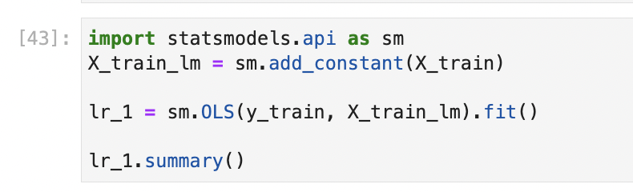

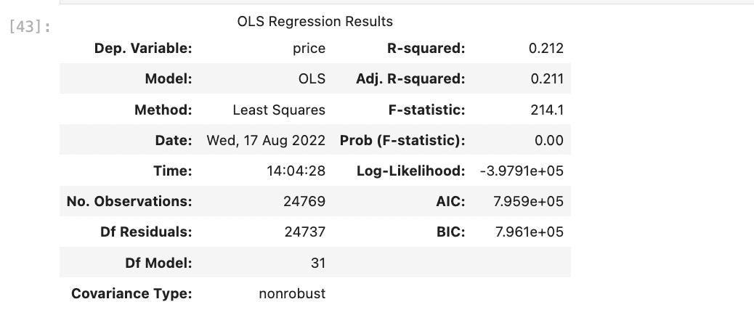

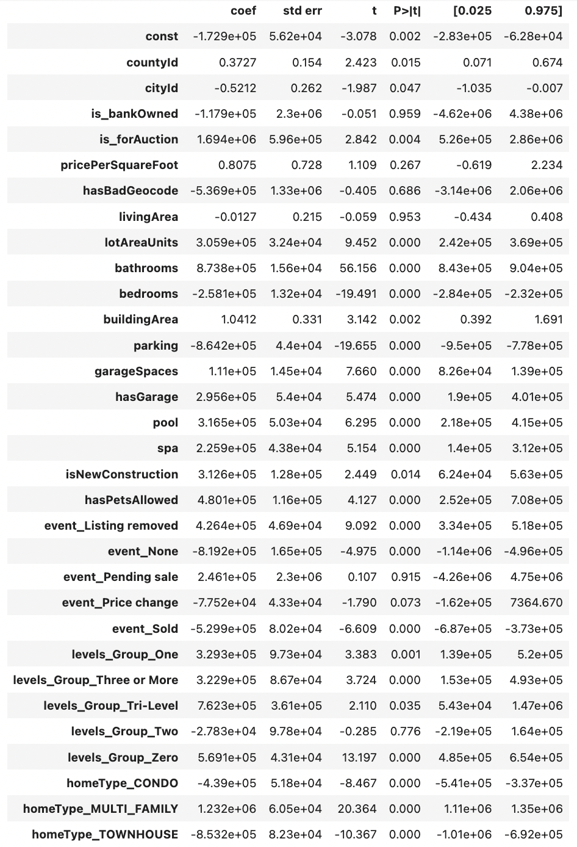

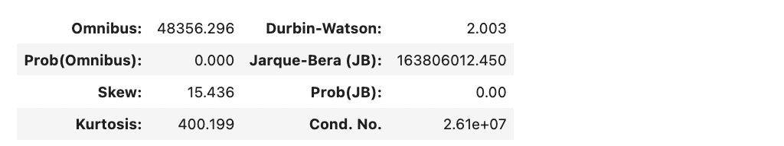

Statsmodel was used for the model as the visualization from OLS is easy to read and comprehensive. A disadvantage of using statsmodel is it is not quite as fast as sklearn when the dataset is as large as this.

There are many important components to the output from the model. The p-value for each of the variables in the model shows which variables have statistical significance and which do not. In general, if the p-value is below 0.05 it can be inferred that this variable is statistically significant in its effect on the price of a home. For example, *cityID* and *countyID* have a low p-value meaning there is a high likelihood that they do have an effect on the price of a home, while *isBankOwned* has a high p-value meaning it does not have a strong effect on the price of a home.

The next important component in the output above is the coefficient. The coefficient is the value of the intercept, and it shows the measurement of how much change the variable will have on the independent variable. If the coefficient is negative, it has an inverse effect on the independent variable, meaning if one rises the other falls.

One of the most important components of the output is the r-Squared value. R-squared indicates how well the independent variables explain the dependent variable. In this analysis, the r-squared value is 0.212. This indicates that the independent variables in the model explain for 21.2% of the change in the target variable.

**Data Summary and Implications**

E.  *Summarize the implications of your data analysis by discussing the results of your data analysis in the context of the research question, including one limitation of your analysis. Within the context of your research question, recommend a course of action based on your results. Then propose****two****directions or approaches for future study of the data set.*

This analysis started with the question: Can a multiple linear regression model be constructed that predicts the best sales price for a home? The hypothesis was that a model could be constructed that predicts the best sales price for a home. After preparing the data for the analysis and creating the model, we can reject the null hypothesis and answer the research question with yes, a model can be constructed that predicts the best sales price for a home. This is determined by the r-squared value of the model which was 0.212. This indicates that the model explains for 21.2% of the variance in the target variable or price of a home. This also indicates that there are other factors influencing the sales price of a home which are not included in the model. Nonetheless, the model allows for a reasonable estimate of the valuation of a home.

As stated previously in this research paper, the analysis was limited by the accuracy and completeness of the data. While there is no indication that the data is not accurate, it is a publicly available dataset and was gathered by observations from someone outside of this analysis and therefore, the accuracy cannot be completely confirmed.

This model can be a great tool for making a statistically backed decision on the valuation of a home. It would be recommended for realtors and brokerages within California to use this model to determine the sales price of a home being put on the market. It can also be used by individuals looking to sale their homes themselves or wanting to ensure their realtor made the best valuation on the home.

There are many different approaches for future study of this data set. One way this data set could be used is to create a time series forecast of home prices. This would give a good indication to where home prices are expected to go in the future. An ARIMA model could be used to make some short-term predictions on the prices of homes. This would be helpful in letting home sellers know the best time to sell their homes at a better valuation. Another approach would be to do a cluster analysis on the home prices. Real estate can be much different across a state or even a city. A cluster analysis would help to identify patterns in the data and determine which areas have the highest or lowest valuations.

**References**

Barr, D. C. (2018, June 28). *Real Estate Valuation Using Regression Analysis – A Tutorial*. Toptal Finance Blog. Retrieved August 9, 2022, from [https://www.toptal.com/finance/real- estate/real-estate-valuation](https://www.toptal.com/finance/real-%09estate/real-estate-valuation)

Potters, C. (2022, July 26). *Variance Inflation Factor (VIF)*. Investopedia. Retrieved August 17, 2022, from [https://www.investopedia.com/terms/v/variance-inflation- factor.asp#:%7E:text=Variance%20inflation%20factor%20(VIF)%20is,only%20that%20sin gle%20independent%20variable](https://www.investopedia.com/terms/v/variance-inflation-%09factor.asp#:%7E:text=Variance%20inflation%20factor%20(VIF)%20is,only%20that%20sin	gle%20independent%20variable).

Roehrich, G. (2022, February 1). *Real Estate California*. Kaggle. Retrieved August 9, 2022, from <https://www.kaggle.com/datasets/yellowj4acket/real-estate-california>

*SAS vs R vs Python – The Battle for Data Science!* (n.d.). TechVidVan. Retrieved August 11, 2022, from <https://techvidvan.com/tutorials/sas-vs-r-vs-python/>

Swalin, A. (2019, July 10). *How to Handle Missing Data - Towards Data Science*. Medium. Retrieved August 11, 2022, from [https://towardsdatascience.com/how-to-handle- missing-data-8646b18db0d4](https://towardsdatascience.com/how-to-handle-%09missing-data-8646b18db0d4)

Uslu, Ç. (2022, March 15). *What is Kaggle*. DataCamp. Retrieved August 10, 2022, from <https://www.datacamp.com/blog/what-is-kaggle>

Valkov, V. (2021, December 9). *Predicting House Prices with Linear Regression | Machine Learning from Scratch (Part II)*. Medium. Retrieved August 9, 2022, from [https://towardsdatascience.com/predicting-house-prices-with-linear-regression- machine-learning-from-scratch-part-ii-47a0238aeac1](https://towardsdatascience.com/predicting-house-prices-with-linear-regression-%09machine-learning-from-scratch-part-ii-47a0238aeac1)